**Martin Packaging Metrics -** Pedro Gouveia, nº 60479

Abstractness: Calculates the Abstractness for each package. Abstractness is defined as the number of abstract classes and interfaces divided by the total number of classes of the package. This metric has a range of [0,1]. A=0 indicates a completely concrete package, A=1 indicates a completely abstract package.

Afferent couplings: Calculates the number of Afferent Couplings for each package. An Afferent Coupling is a reference from a class or interface external to the package to a class or interface internal to the package. That is Afferent Couplings are Arriving references, Efferent Coupling are Exiting or Escaping references. References from test classes and library classes are not included.

Efferent couplings: Calculates the number of Efferent Couplings for each package. An Efferent Coupling is a reference from a class or interface internal to the package to a class or interface external to the package. That is Afferent Couplings are Arriving references, Efferent Coupling are Exiting or Escaping references. References to test classes and library classes are not included.

Distance from the main: Calculates the Distance from the Main Sequence for each package. The Distance from the Main Sequence metric is defined as the absolute value of 1 - Abstractness - Instability (|1 - A - I|). This metric has a range of [0,1], where the closer D is to 0, the better.

Instability: Calculates the Instability of a package. The Instability of a package is defined as the package's Efferent Couplings divided by the sum of the package's Afferent and Efferent Couplings (Ce÷(Ca+Ce)). This metric has a range of [0,1]. I=0 indicates a maximally stable package, I=1 indicates a maximally unstable package.

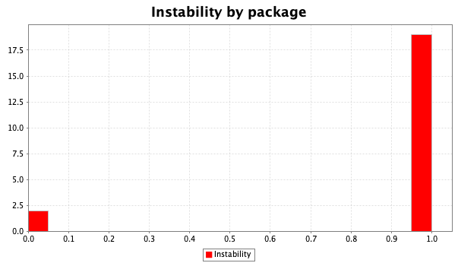

Almost every package has an instability of almost 1, which indicates that almost every single package is a maximally unstable package. This means that every package has a lot of efferent couplings resulting in a huge danger when changing code. This is a big code smell that we have to have in consideration when developing our new features.